ROLL of HONOUR
POST OFFICE
BARNARD CASTLE

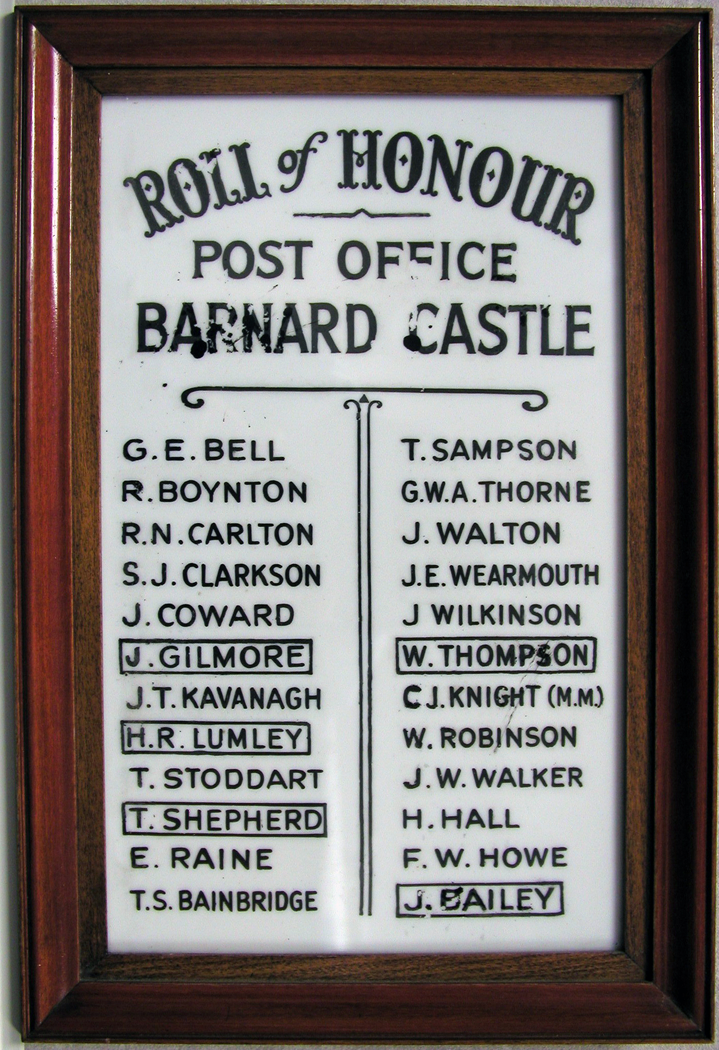

 John BAILEY, Postman, Private 46685, 19th Battalion, Durham Light Infantry.
Killed in action 9th August 1918. Aged 18. Born and resident Barnard Castle, enlisted Newcastle. Only son of Blacksmith John and Mary Elizabeth Bailey, of 4, Wood St., Barnard Castle, County Durham.
Buried in LINDENHOEK CHALET MILITARY CEMETERY, Heuvelland,
West-Vlaanderen, Belgium. Plot II. Row A. Grave 10.

Thomas Sowerby BAINBRIDGE, Postman. Private 119437, Royal Army Medical Corps No's 12 & 34 Company Woolwich R.A.M.C.
Formerly of Mickleton. Born 1879. Lived in Barnard Castle, with his wife Alice at the Coach & Horses Yard, Galgate. Record WO 364/113. Discharged 11th February 1918 as being no longer fit for war service aged 38 years 9 months. Military character: Good. Conduct satisfactory - Trained first aid and ambulance duties. Height 5 feet 9 inches, complexion fresh, eyes blue, hair dark brown.

George Edward BELL, Postman, Private 23/30092, 23rd Battalion, Durham Light Infantry transferred to Private 112665, 188th Company, Labour Corps.
He had a half-sister: Mabel Ellen Crowther of Doctor Hill, Mickleton, Yorkshire. Resident: 21 Hill Terrace, Middleton-in-Teesdale. Attested 21 years 5 months. Unmarried. Enlisted in Bishop Auckland 12 December 1915 and recruited in Newcastle-upon-Tyne 25 January 1916 to 23rd Battalion, Durham Light Infantry. Medical examination in Sunderland 25 January 1916. He served at Home 12 December 1915 to 8 May 1916, then France to 9 May 1916, embarking at Folkstone to Boulogne 10 May 1916. He return to United Kingdom for respite 25 September 1918 to 9 October 1918. He was demobbed on 29 June 1919.

Roy BOYNTON, According to the Post Office Appointment Book he was appointed as a Middleton-in-Teesdale Rural Postman in June 1913.
His British Army Service Records are currently unavailable.
Robert Nixon CARLTON, Postman, Private 26442, Highland Light Infantry Yorkshire Regiment. Son of George Robert Carlton, of Close (later Rose) Cottage, Cotherstone. He also served a Exchange Telephone Clerk at 65th Law Div Hdqrs, R.A.M.C. 143788. Record WO 363/C373.

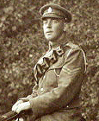
Stanley James CLARKSON, Postman and Grocer's Assistant.
Corporal TT/03019, Royal Army Veterinary Corps.
Born: 1891. Son of John and Jane Clarkson. Resident Pensbury, Cotherstone. Unmarried on Enlistment. In 1925 he married Emily Gertrude Wright in Liverpool. They didn't have any children. He died at the age of 60 at Waterloo, Liverpool, in November 1951. Stanley's great niece, June Luckhurst of Ingleton, remembers him as a fine looking and amiable man who, like most former soldiers, never talked about the war.

Jonathan William COWARD, Assistant Postman, Sapper 463168, 3rd Royal Engineers (Telegraph Messenger - 1911 Census). Born 1895. Son of Margaret Ann Coward and brother of Amy Barnes (sister). Resident Barnard Castle. Family home removed to 33 Coronation Street, Barnard Castle during the war. Attested aged 17. Unmarried. Attestation and initial training to The 6th Battalion, Durham Light Infantry 6th March 1912. Recruited on 16 November 1914 as Telegraphist Officer. Transferred 27 January 1915 as Sapper 1809, No. 4 Section, Northumbrian Division Signal Company, Royal Engineers stationed at Gateshead. Medical examination 20 May 1912. With the British Expeditionary Forced (B.E.F.) in France from 17 April 1915 to 8 May 1917 with only 2 weeks leave from 2 May 1915 to 24 May 1915. He was hospitalised in Wharncliffe War Hospital, Sheffield for 2 days 3 February 1916 to 4 February 16 with a shrapnel wound to his left cheek. Demobilised on 21 July 1919.

John GILMORE, Sergeant 8403, 6th Battalion, Alexandra, Princess of Wales's Own (Yorkshire Regiment). Killed in action at Gallipoli 21st August 1915.
Born and resident Barnard Castle, enlisted Richmond, Yorkshire. No known grave. Commemorated on HELLES MEMORIAL, Turkey. Panel 55 to 58.

Harold HALL (M.M.), Postman, Second Lieutenant, Royal Engineers. Born Romaldkirk 1893 to Frances Hall, brought up by his grandparents, John and Sarah Hall. He joined the Territorial Force, 6th Battalion, Durham Light Infantry in 1912. Resident Pinners Cottage, Cotherstone, Yorkshire. Transferred 1914 to Signal Company as Sapper 1810/463169 Royal Engineers. Married Caroline Margaret Parker March 1915. Posted to France with the British Expeditionary Force (B.E.F.) 17 April 1915. Promoted Serjeant March 1916. Awarded the Military Medal (M.M.) for bravery in action [London Gazette 27 October 1916 Issue 10479]. Commissioned as a 2nd Lieutenant, Royal Engineers in 1917. Discharge at Chatham on 23 March 1921. Died on Armistice Day November 11, 1952 in United Kingdom.
Note: The decoration of the Military Medal (M.M.) omitted from the inscription.

Frederick Walter HOWE, Postman. Resident Broadgates, The Bank, Bd Castle.
Teesdale Talk: “Postman tale stirs memories of tragic day”
From the archive, first published Saturday 14th Jan 2006.
A dreadful tragedy has been recalled following a report in The Northern Echo about a display featuring Teesdale's postmen in decades gone by.
Harold Howe, who lives in Barnard Castle, contacted me [Jim McTaggart] after reading it to relate how his father, Fred Howe, was killed.
He was a popular postman who cycled all over Marwood and Langleydale delivering letters and parcels when the sorting office was on The Bank. But while pedalling on his round on a Saturday in May, 1928, when he was 37, he was fatally injured in a collision with a car near Kinninvie.
[Fred Howe is listed as F.W. Howe on the Barnard Castle Post Office Roll of Honour. To have survived the war only to be killed in a car crash is a dreadful tragedy indeed.]
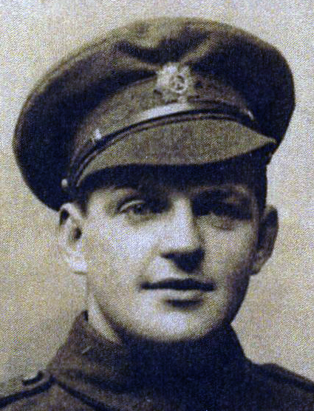
John 'Jack' Thomas KAVANAGH, Private M2/048700, Army Service Corps. Postman (Driver) - given as Motor Lorry Driver (possibly GPO contractor). Born around 1896, served in France with the British Expeditionary Force (B.E.F.). Married to Margaret Elizabeth (nee Coates); son of Joseph Kavanagh, father and hemp rope maker - formerly of Ireland. Resident of The Vicarage, Bridgend, Startforth, Barnard Castle but demobbed to 37 Newgate. Attested aged 22, born Blagraves House, The Bank, Barnard Castle in 1892. Single on Attestation Papers but subsequently married 28 November 1915. Enlisted at Grove Park. Served at Home from 9 February 1915 to 3 March 1915, with the British Expeditionary Force (B.E.F.) 4 March 1915 to 6 May 1919, then returned Home 7 May 1919 to 4 June 1919. Demobilised at Ripon Dispersal Unit 8 May 1919 with 6 Petrol Company, Royal Army Service Corps.
Jack's daughter, Myra Lycett, has supplied a 'potted history' of her 'lovely Dad'. She believes he 'joined up' with the Durham Light Infantry (DLI) but had several moves between Company's. When the trenches were 'at rest' he was a barber. Also, he was a great sportsman being in the Army boxing and football teams. He returned to civilian life as a driver for J P Hunter, a greengrocer in Barnard Castle and lived to the ripe old age of 82. Greatly loved and respected throughout his life Jack was a Barney man - always!
Charles John KNIGHT, (M.M.) Yorkshire Regiment, Service #30582.
Awarded the Military Medal (M.M.) 28 September 1917 for ‘Bravery in the Field’ in Flanders. From the Discharge Documents. Serjeant 471792, born Wandsworth, Surrey, in 1879, of the 148th Company, Chinese Labour Corps was transferred to the Reserve 24 February 1919. (The usual reason for transfers to the Labour Corps was that a man was no longer A1 fighting fit for front line service - as was the case with John transferring from the 2nd Battalion. Yorkshire Regiment as he suffered an aggravated hernia/rupture caused by coughing through a gas attack in France July 1918.) The document cover is endorsed Cotherstone, Darlington. Record WO 363/453.
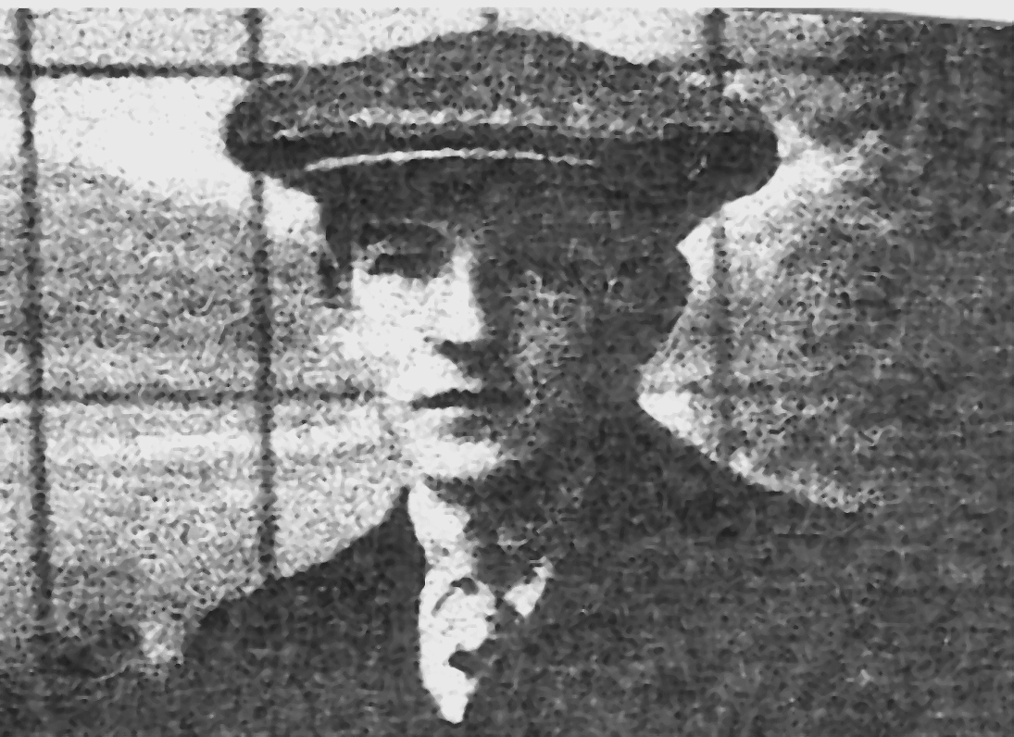
Harold Robert LUMLEY, Private PS/8964, 20th Battalion, Royal Fusiliers (City of London Regiment). Died of wounds 30th July 1916. Born and enlisted Barnard Castle, resident New Shildon (46 Newgate in 1901 Census).
Buried in CAUDRY OLD COMMUNAL CEMETERY, Nord, France. Plot/Row/Section A. Grave 2.

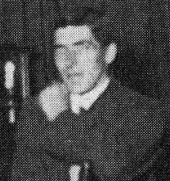
Ernest RAINE, Private 201084 (formerly 48573), 81st Coy Labour Corps. Postman and Farmer. Lived in Lathkirk, Middleton-in-Teesdale. From the 1901 Census his father, William Raine, was a Sub Postmaster and his mother, Mary, a Post Office assistant. Record WO 364/5580. Resident , Middleton-in-Teesdale, via Darlington. Attested aged 29 years 11 months. Born 1887. Enlisted 25 January 1917. Attested at Richmond 10 May 1917. Served at Home 10 May 1917 to 10 June 1917; France from 11 June 1917 to 1 July 1917; hospitalised at Bologne 29 June 1917 “Goitre”; invalided to United Kingdom 1 July 1917. Medical Board Report made 23 November 1917. Appeared before the Appeal Board 21 January 1918 requesting an allowance for 2 children. Discharged as no longer physically fit for War Service, at Nottingham, 24 December 1917. Extensive subsequent medical examinations at Darlington 7 October 1918 to 10 August 1922. He had a character award quoted as “Well conducted during short service”.
'Return to Civvy Street': continued as the local postman until his eventual retirement c. 1950 achieving 45 years long service.
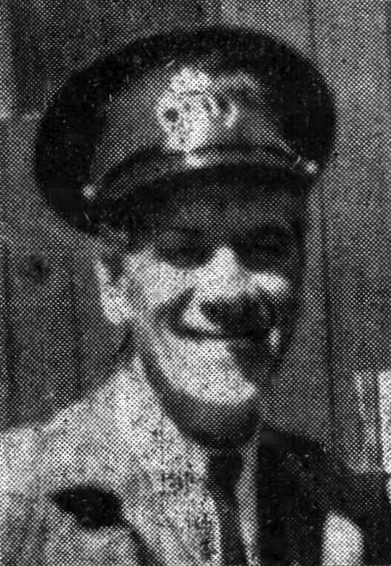
Wilfred Joseph ROBINSON, Born Lartington in 1884 was appointed Assistant Postman in August 1910 becoming a substantive Rural Postman in Lartington February 1911. The 1911 Census shows him as working for the GPO from home which suggests Lartington was a 'Branch Post'. His British Army Service Records are currently unavailable.
Thomas SAMPSON, A native of Hull Thomas Sampson resided in Demeses Mill House, Barnard Castle. He enlisted in 1905 serving 8 years with the 17th Lancers in India. Being a Reservist he went to war in France in 1914 and eventually demobbed in February 1919. (Details and photograph of Thomas Sampson taken from a newspaper cutting of The Teesdale Mercury 24 January 1945.) Also, member of the Post Office Home Guard 8 September 1940 until it disbanded in 1945.

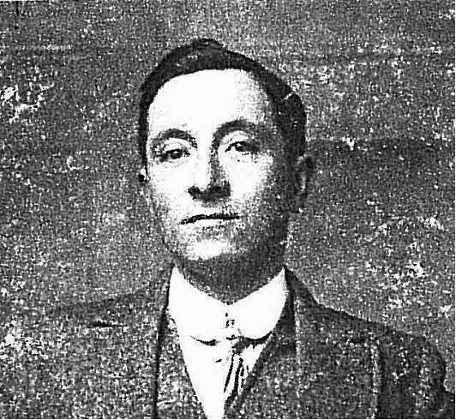
Thomas SHEPHERD, Private D/22066, 10th Battalion, Duke of Wellington's (West Riding Regiment). Killed in action 27th October 1918. Aged 34. Born Cleatham, Durham, enlisted Dalton, Newcastle-on-Tyne, resident Baringham, Durham. Husband of Florence Shepherd, of Barningham, Barnard Castle, Co. Durham. Formerly 301904, Royal Army Service Corps. He was the Sub Postmaster at Barningham before enlisting. Buried in TEZZE BRITISH CEMETERY, Italy. Plot 4. Row D. Grave 2.

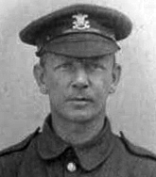
Thomas STODDART, Welsh Regiment. From the 1911 census Thomas, aged 28, worked as an assistant to his widowed mother, Margaret Jane Stoddart, Subpost-mistress, at the Post Office / News Agency, 84 Galgate, Barnard Castle. Born circa 1883. His British Army Service Records are currently unavailable.
Photograph Courtesy & Copyright © Bill Stoddard 2014

William THOMPSON, Private 235403, 4th (Reserve) (Territorial Force) Battalion, York and Lancaster Regiment. Died in the United Kingdom 21st August 1918. Aged 37. Born and enlisted Middleton-in-Teesdale, Durham. Husband of Aline M. Thompson. Formerly 31612, Yorkshire Light Infantry. Buried in ST. MARY CHURCHYARD, MIDDLETON-IN-TEESDALE, Durham.

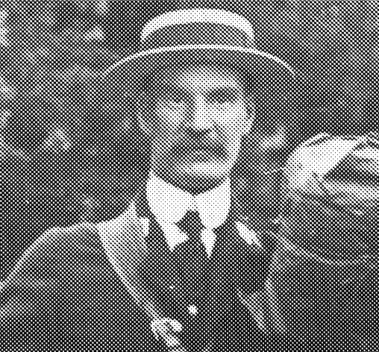
George W A THORNE, Cotherstone Postman - died 1930. The Post Office appointment records (Thorn without the 'e') show George starting as a Rural Postman in August 1911.
His British Army Service Records are currently unavailable.

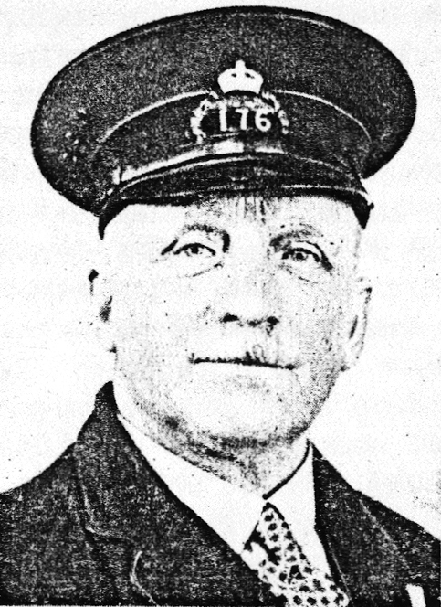
John William WALKER, Postman. Private 237739, Shoeing Smith, Royal Engineers. Born 1879. Husband of Mary Walker (nee Forest), married at Laithkirk, Mickleton, October 1902. Resident Eastwood, Egglestone, Darlington; father of Doris Mary, born 4 October 1903 and Margaret Evelyn, born 8 November 1908. Attested aged 36 years 11 months. Enlisted at Barnard Castle 10 December 1915. Medical examination at Durham 6 October 1912. Mobilised 2 February 1917. Served until 6 February 1919 as a shoeing smith with the Royal Engineers (Signals). Recruited as 237739, Royal Engineers. Training qualifications Certificate of Trade Proficiency 1 May 1917, for Royal Engineers, Signal Depot, Haynes Park, Beds. Promoted Shoeing & Carriage Smith 19 May 1917. Hospitalised at Cherryhinton Military Hospital, Cambridge 10 July 1917 to 10 September 1917, 62 days, suffering from 'Disease'. Demobilised at Chatham 6 March 1919.
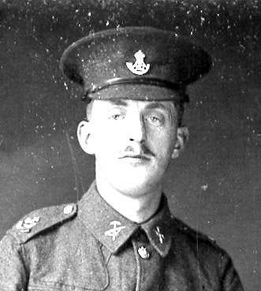
John 'Jack' WALTON, Army Ordnance Corps, Service #038340. Holwick Postman. Born 1893. Appointed as a Rural Postmen November 1907, Holwick. Enlisted Barnard Castle 6th Dec 1915 joining the 22 (8) Battalion, Durham Light Infantry (Pioneers) as 22/824, later transferring to the Army Ordnance Corp as 038340. 1916 embarkation postcard, postmarked West Hartlepool 11:45 am 11 February 16 from 'Jack' Walton to his 'Mother & All' at Stoney Keld, Bowes, Darlington – “I think we shall be moving in the morning” (February 12, 1916 to France).
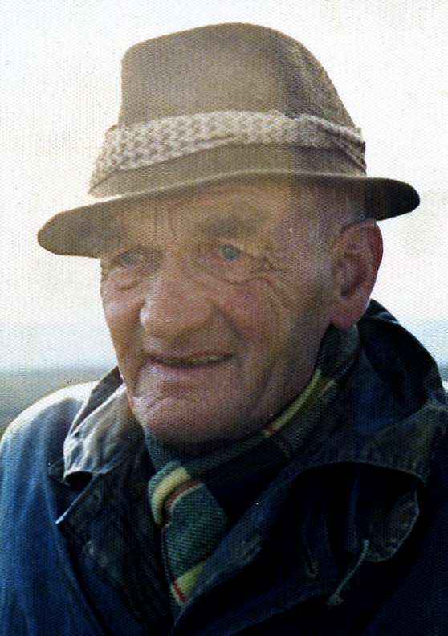
John Edgar WEARMOUTH, Newbiggin Postman. Born 1895 (2nd quarter). Son of John Wearmouth (Sub-Postmaster and Farmer at home address), Newbiggin Post Office, Middleton-in-Teesdale, Barnard Castle. Enlisted aged 20 years 6 months, unmarried. Attested at Bishop Auckland 4 March 1916, allocated as 4411, 6th Battalion, Durham Light Infantry. In France 9. September 1916 to 13. October 1917. Suffered gunshot wounds to his Left side (HB8377). Awarded a disability pension September 1919 and demobilised 28 September 1919. Died 4th quarter 1977.

Joseph WILKINSON, [Name not highlighted in black on the RoH plaque] Private 30303, 10th Battalion, East Yorkshire Regiment. Killed in action 12th April 1918. Aged 35. Born and enlisted Barnard Castle. No known grave. Commemorated on PLOEGSTEERT MEMORIAL, Hainault, Belgium. Panel 4. Born Barnard Castle, Co. Durham. In the 1911 Census he is resident at The Red Well Inn, Barnard Castle. Attested 11 December 1915. Sent to the Army Reserve 12 December 1915, mobilised 18 December 1916, posted 19 December 1916. Reported missing in France [C.1552] 12 April 1918 ["Recorded for Official Purposes as having died (on or since)" E/759734/1]. Transferred from Reserve (50546) to West Yorkshire Regiment 21 March 1917. Served at Home 11 December 1915 to 20 March 1918; in France 21 March 1917 to 11 October 1918; at Home (HB8749) 12 October 1917 to 29 March 1918; in France 30 March 1918 until his death.
From the 'STATEMENT of addresses...' his widow, Beatrice A Wilkinson, is residing at Guys Cottage, Barnard Castle, with their five children:
Louisa b. May 8 1906
John b. May 3 1908
Thomas H b. Dec 5 1911
Oliver? b. July 12 1915
Brenda b. May 2 1917
His brother John at the Red Well Inn and his sister, Catherine Hunter at 3 Victoria Terrace, Barnard Castle.
The statement is witnessed by the Vicar of Barnard Castle, Henry Bircham, on 1st July 1919.
Details taken from the 'British Army Service Records 1914-1920' courtesy of The National Archives.
Note: The omission on the plaque of a black border around J Wilkinson's name denoting his death.

BARNARD CASTLE POST OFFICE WAR MEMORIAL
World War 1 - Detailed Information
Compiled and copyright © Dave Charlesworth, Royal Mail Teesdale, 2006-2014.
Additional research by Martin Edwards, www.roll-of-honour.com
Further information from Briony Kay of The National Archives and
Mrs Sarah Quinn of The Commonwealth War Graves Commission.
Also, the 'final few' found and researched by Andy Denholm, chairman of
West Cornforth Local History Society.
Photos, extracts etc. copyright © of their respective owners.

